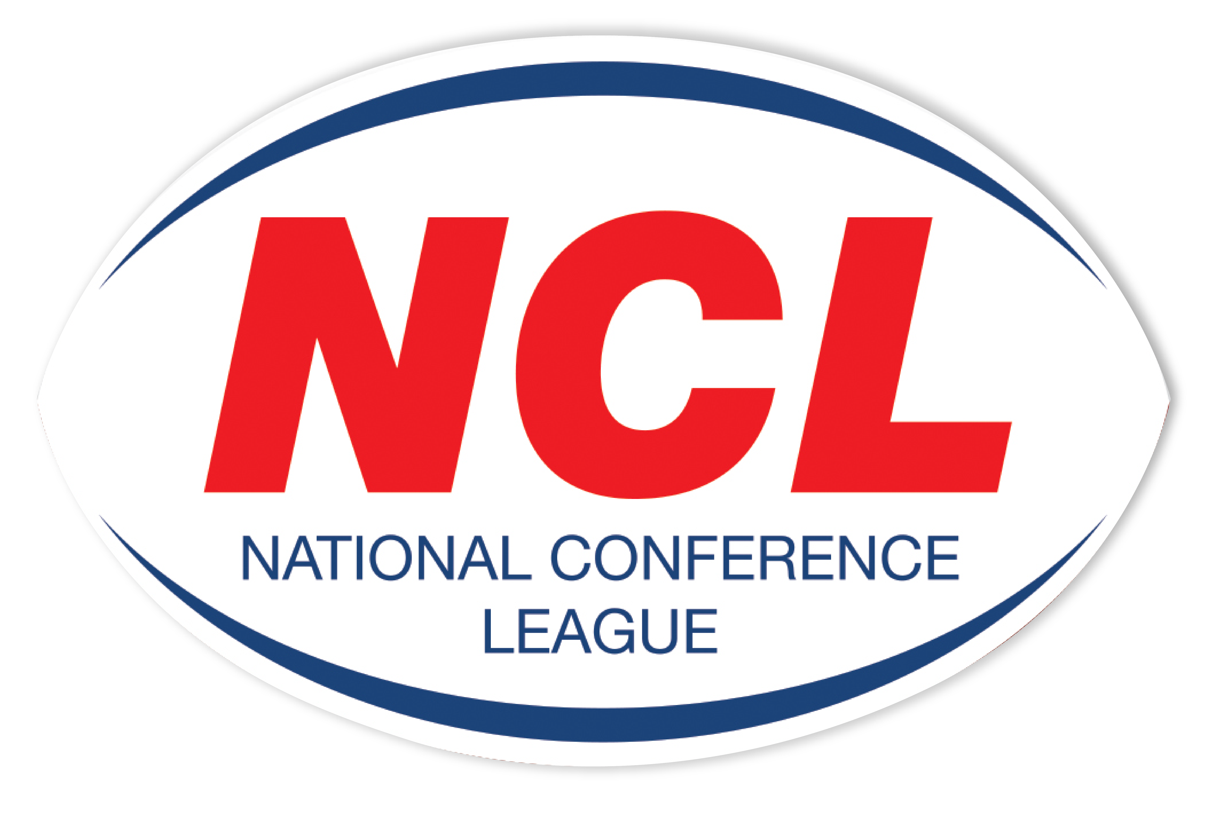NATIONAL CONFERENCE LEAGUE 2022

Minutes of the Discipline Hearing held on Wednesday 30th March 2022
 | Name | Club | Match Date | Present | Nature of Offence | Decision | Suspension Starts | Right of  Appeal
NCL 010 | Jacob Chamberlain | Crosfields | 26 02 202 | Personal | Match Official Verbal Threats  Law 15.1 (I)  Grade H  Intentionally or Continuously Breaks the Laws of the Game  Law15.1 (E)  Grade A-H | Not Guilty  Guilty  2 Match Ban Reduced To 1 Game For Guilty Plea  £20 Fine | NA  02 April 2022 | NA  Yes
NCL 012 | Reece Hamlet | Rochdale Mayfield | 05 03 2022 | Personal | Punching To Head | Adjourned To Next Hearing
NCL 013 | James Sheldon | Batley Boys | 12 03 2022 | Written | Tripping | Guilty  2 Match Ban Reduced to Sending Off Sufficient For Guilty Plea and Previous Good Record | NA | Yes
NCL 014 | Liam Brown | Hunslet Warriors | 12 03 2022 | Personal | Head Butt | Not Guilty | NA | NA
NCL 015 | Jermaine Ruan | Stanningley | 12 03 2022 | Written | Head Butt | Guilty  2 Match Ban Reduced To Sending Off Sufficient For Guilty Plea and Previous Good Record | NA | Yes
NCL 016 | Michael Cashin | Oldham St Annes |  | Called In | Playing Whilst Banned | Guilty  2 Match Ban | 02 April 2022 | Yes
NCL 017 | Chris Hope | Oulton Raiders | 19 03 2022 | Personal | High Tackle | Guilty 2 Match Ban Reduced To 1 Game For Previous good Record  Fine £20 | 02 April 2022 | Yes
NCL 018 | Nick Gale | Hunslet Warriors | 19 03 2022 | None | Foul & Abusive Language To MO | Guilty 8 Game Touchline Ban and From All Match Day Activities. It is a required that DBS,SPC & CoachRight Quals are obtained before ban is lifted  Fine £100 | Immediately | No
NCL 018A | Club | Hunslet Warriors | 19 03 2022 |  | Coach Not Registered On GameDay | Guilty  £100 Fine | NA | Yes
NCL 019 | Daniel Barcoe | Stanningley | 19 03 2022 | Written | Punching | Guilty  4 Match Ban Reduced to 2 Games For Guilty Plea and Previous Good Record  Fine £40 | 02 April 2022 | Yes
NCL 021 | Paul Fletcher | Hull Dockers | 19 03 2022 | Written | High Tackle | Guilty 3 Match Ban Reduced To 1 Match For Guilty Plea and Previous Good Record  £20 Fine | 02 April 2022 | Yes
NCL 027 | Ben Gale | Hunslet Warriors | 26 03 2022 | Personal | Head Butt | Guilty  1 Match Ban  £20 Fine | 02 April 2002 | Yes

The administration fee set aside for clubs wishing to contest the content of a match official’s report is £20, however this becomes £40 in the event of representation for two players or £60 should three players, from the same club, having been dismissed in a game wish to seek personal representation at the next discipline hearing.
All disciplinary fines imposed by the National Conference League must be remitted directly in full to the Administrator for receipt at the address below on or before
6th April 2022. The 28 day ruling given for payment applies from the original hearing date and not the date of any appeal decision.
Please Note – Notification of Suspensions/Games Served The League will not, in the run up to the 28 day expiry date window, issue reminders to clubs having failed within this period allowed to settle fines imposed. This template acts as the official notice issued by the National Conference League confirming the suspension or otherwise of players. Players against whom fines are imposed are NOT eligible for selection by their club.
Clubs must ensure that payments (Banker Cheques in favour of “NCL”) are secure as losses by post unless proven beyond all reasonable doubt cannot be classified as an excuse for non-payment by the final deadline date as issued in this communication.

Alternatively, clubs may, if they so wish and have a facility available to do so payments on-line directly to the NCL account. The NCL account number is: 29678277 Sort Code 606005 and name of account “National Conference League” When exploiting this option clubs must forward to me on the actual date of payment an email confirming that it has been made and the reason for the direct transaction. Any payment not received within 28 days from the date of imposition will mean the original fine being doubled accordingly. The NCL is not obliged to provide clubs with reminders warning them of a timescale for payment having elapsed without receipt
A Smith (NCL Administrator) Operations Dept, RFL, Cwm Ban Fawr, Llanfynydd, Carmathen, SA32 7UB.

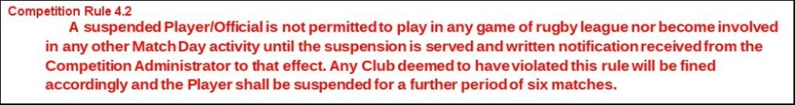

A Smith (NCL Administrator) Operations Dept, RFL, Cwm Ban Fawr, Llanfynydd, Carmathen, SA32 7UB.

