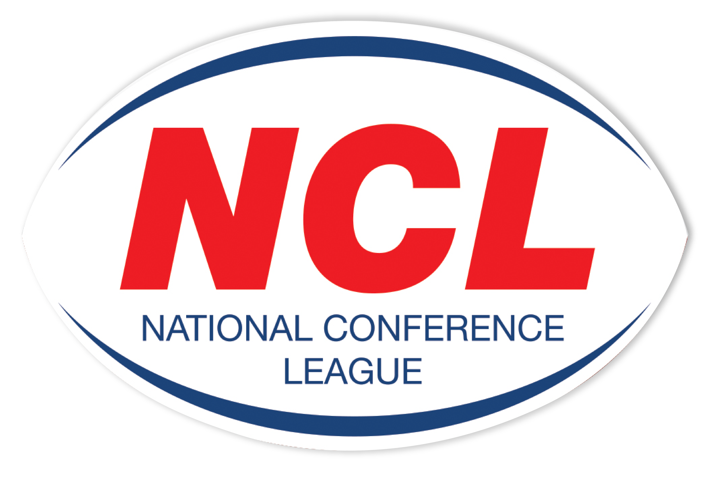NATIONAL CONFERENCE LEAGUE 2022

Minutes of the Discipline Hearing held on Monday 25th April 2022
 | Name | Club | Match Date | Present | Nature of Offence | Decision | Suspension Starts | Right of  Appeal
NCL 032 | Robbie Valentine | Ince Rose Bridge | 02 04 2022 | Personal | Careless High Tackle  Law 15.1 b | Guilty  1 Match Ban Reduced To Sending Off Sufficient Due To Guilty Plea | NA | Yes
NCL 033 | Jamie Tracey | Thatto Heath | 02 04 2022 | Personal | Repeated Punching To Head  Law 15.1a | Guilty  8 Matches  £100 Fine | Immediate | Yes
NCL 034 | Cole Walker-Taylor | Wath Brow | 02 04 2022 | Personal | Entering The Field Of Play Without Permission  Law 15.1 h | Guilty  1 Match Ban Reduced To Sending Off Sufficient Due To Previous Good Record | NA | Yes
NCL 035 | Simon Topping | Oldham St Annes | 02 04 2022 | Written | Intention Late High Tackle  Law 15.1b | Guilty  6 Match Ban  £100 Fine | Immediate | Yes
NCL 036 | Thomas Hill | York Acorn | 02 04 2022 | Personal | Lashing Out  Reaction To Opponent | Guilty  2 Matches Reduced To 1 Match For Guilty Plea  £20 Fine | 30 04 2022 | Yes
NCL 038 | Jordan Morris | Pilkington recs | 02 04 2022 | Called In | Spitting  Law 15.1i | Not Guilty | NA | NA
NCL 039 | Club | York Acorn | 02 04 2022 | Called In | Unacceptable Behaviour & Language  Law 15.1 k | Guilty  £175 Fine  1 NCL Game To Be Played Behind Closed Doors Suspended Until End Of 2023 Season | NA | Yes
NCL 040 | Connor Wick | Hunslet Warriors | 09 04 2022 | Written | Repeated Punching To Head  Law 15.1a | Guilty  8 Matches Reduced To 6 For Previous Good Record & Guilty Plea  £100 Fine | Immediate | Yes
NCL 041 | Nick Gale  Spectator | Hunslet Warriors | 09 04 2022 | None | Threatening Words To MO  Law 15.1 i | Guilty  2 Year Ban From Attending Any RFL Community Game Or Training Session | Immediate | Yes
NCL 042 | Club | Hunslet Warriors | 09 04 2022 | Called In | Failing To Control Their Supporters | Adjourned | NA | NA
NCL 043 | Neil Wall | Bradford Dudley Hill | 09 04 2022 | Personal | Elbow to The Head  Law 15.1 a | Guilty  3 Matches  Reduced To 2 For Previous Good Record | 30 04 2022 | Yes
NCL 044 | Pat Wells | Egremont Rangers | 16 04 2022 | Personal | Dangerous Tackle  Law 15.1 d | Guilty  3 Matches Reduced To 1 Match For Guilty Plea and Previous Good Record  £20 Ban | 30 04 2022 | Yes
NCL 045 | Paul Menell | Dewsbury Moor | 23 04 2022 | Written | High Tackle | Adjourned To Next Hearing
NCL 046 | Lew Fewlass | Myton | 23 042022 |  | Head Butt | Adjourned To Next Hearing

The administration fee set aside for clubs wishing to contest the content of a match official’s report is £20, however this becomes £40 in the event of representation for two players or £60 should three players, from the same club, having been dismissed in a game wish to seek personal representation at the next discipline hearing.
All disciplinary fines imposed by the National Conference League must be remitted directly in full to the Administrator for receipt at the address below on or before
6th April 2022. The 28 day ruling given for payment applies from the original hearing date and not the date of any appeal decision.
Please Note – Notification of Suspensions/Games Served The League will not, in the run up to the 28 day expiry date window, issue reminders to clubs having failed within this period allowed to settle fines imposed. This template acts as the official notice issued by the National Conference League confirming the suspension or otherwise of players. Players against whom fines are imposed are NOT eligible for selection by their club.
Clubs must ensure that payments (Banker Cheques in favour of “NCL”) are secure as losses by post unless proven beyond all reasonable doubt cannot be classified as an excuse for non-payment by the final deadline date as issued in this communication.

Alternatively, clubs may, if they so wish and have a facility available to do so payments on-line directly to the NCL account. The NCL account number is: 29678277 Sort Code 606005 and name of account “National Conference League” When exploiting this option clubs must forward to me on the actual date of payment an email confirming that it has been made and the reason for the direct transaction. Any payment not received within 28 days from the date of imposition will mean the original fine being doubled accordingly. The NCL is not obliged to provide clubs with reminders warning them of a timescale for payment having elapsed without receipt
A Smith (NCL Administrator) Operations Dept, RFL, Cwm Ban Fawr, Llanfynydd, Carmathen, SA32 7UB.

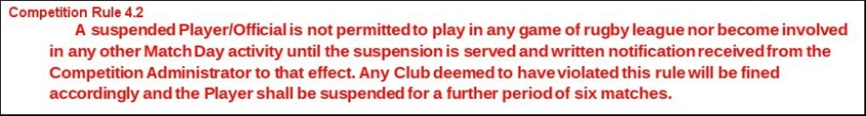

A Smith (NCL Administrator) Operations Dept, RFL, Cwm Ban Fawr, Llanfynydd, Carmathen, SA32 7UB.

