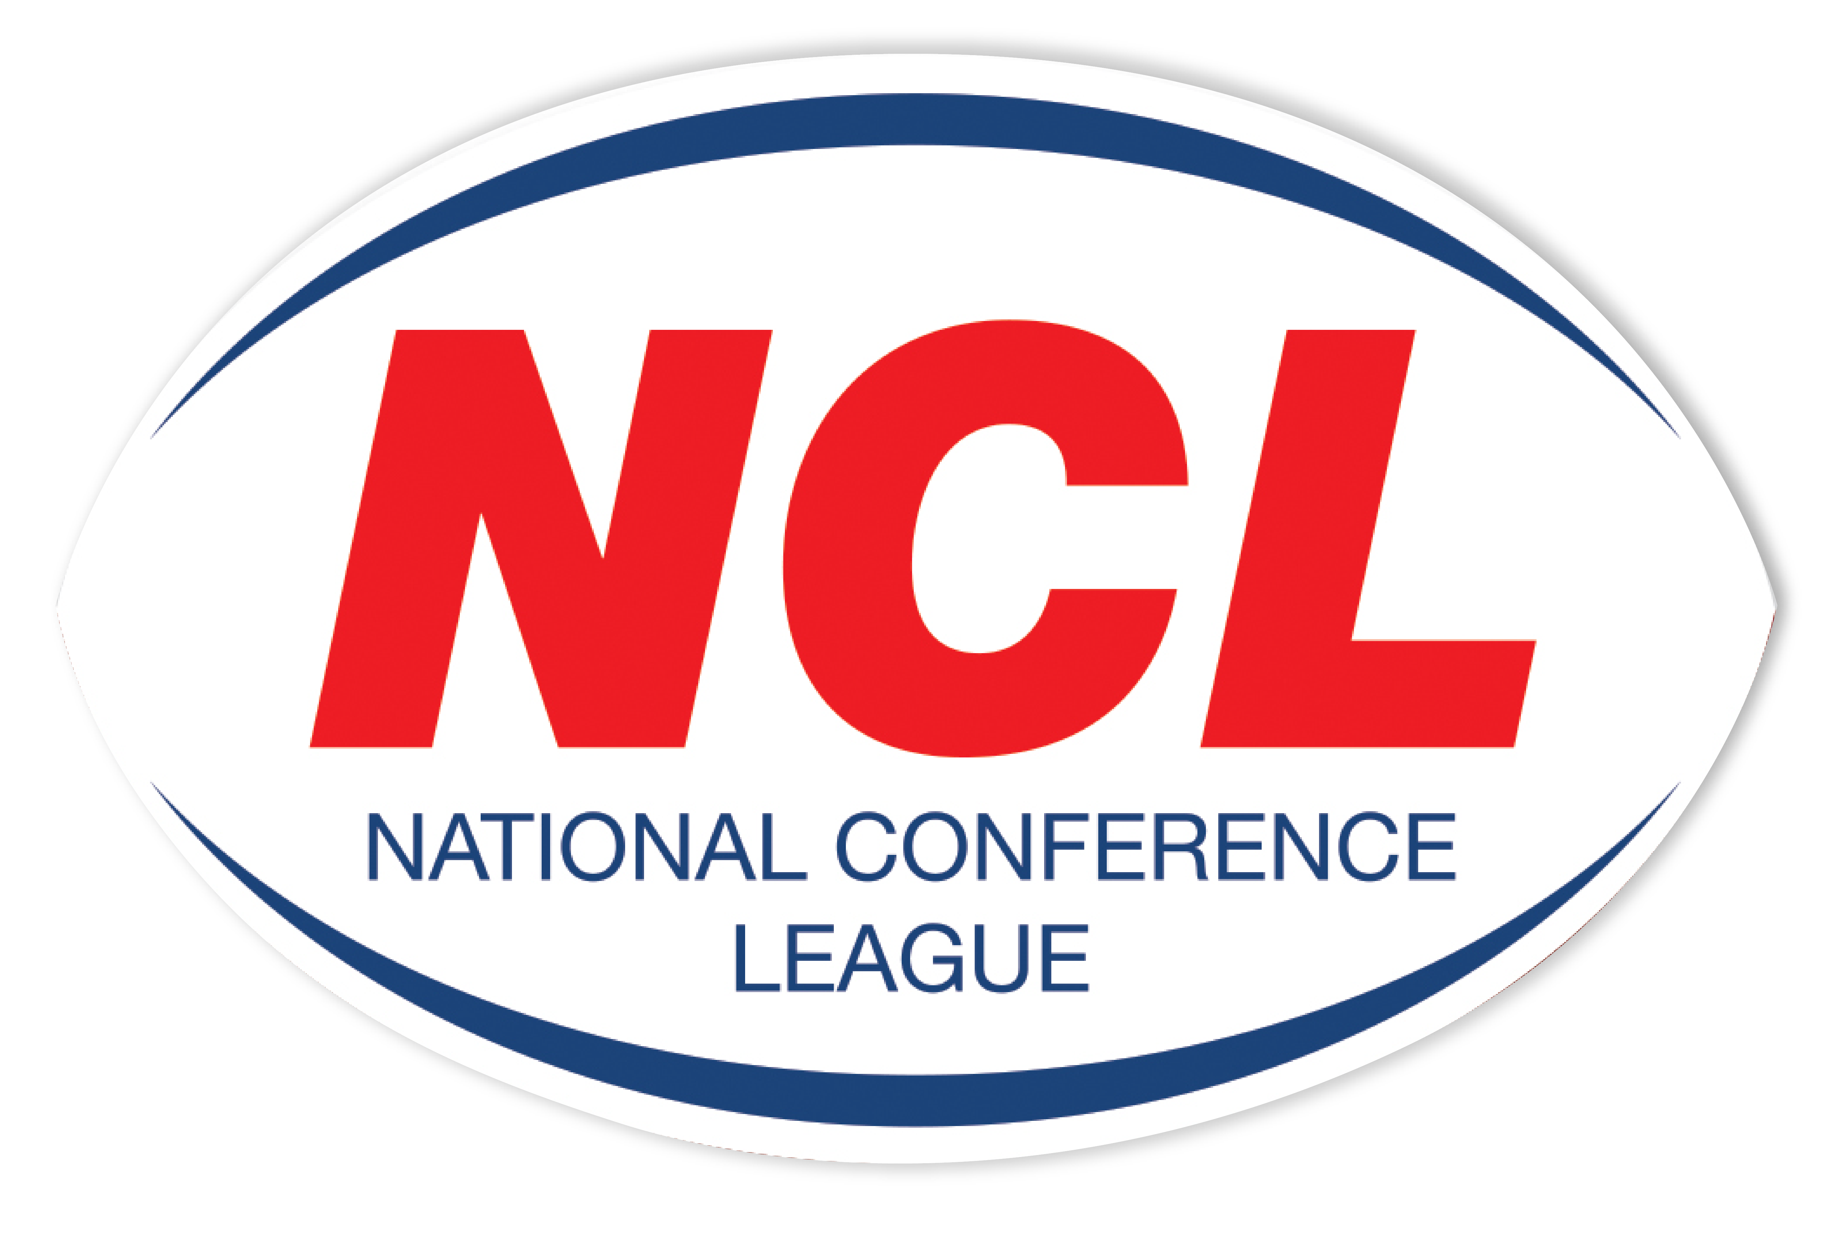NATIONAL CONFERENCE LEAGUE 2022

Minutes of the Discipline Hearing held on Monday 21st February 2022
 | Name | Club | Match Date | Present | Nature of Offence | Decision | Suspension Starts | Right of  Appeal
NCL 03 | Club | Ince Rosebridge | 12 02 2022 | None | Brawl  Law 15.1 (A)  Fine
NCL 04 | Club | Clock Face Miners | 12 02 2022 | None | Brawl  Law 15.1 (A)  Fine
NCL 05 | Andy Collier | Ince Rosebridge | 12 02 2022 | Personal | Punching to the Head;  One on One  Law 15.1 (A)  Grade E - H
NCL 06 | Mike Fields | Clock Face Miners | 12 02 2022 | None | Punching to the Head;  Self Defence  Law 15.1 (A)  Grade B - D
NCL 07 | Jamie Malone | Ince Rosebridge | 12 02 2022 | Personal | Running In and Punching Opponent to the Head  Law 15.1 (A)  Grade H
NCL 08 |  | Crosfields | 26 02 2022 |  | Punching To The Head
NCL 09 |  | Crosfields | 26 02 2022 |  | Other Contrary Behaviour  Verbal Threats To Referee
NCL 10 |  | Leigh Miners | 26 02 2022 |  | Punching To The Head

The administration fee set aside for clubs wishing to contest the content of a match official’s report is £20, however this becomes £40 in the event of representation for two players or £60 should three players, from the same club, having been dismissed in a game wish to seek personal representation at the next discipline hearing.
All disciplinary fines imposed by the National Conference League must be remitted directly in full to the Administrator for receipt at the address below on or before
21st March 2022. The 28 day ruling given for payment applies from the original hearing date and not the date of any appeal decision
Please Note – Notification of Suspensions/Games Served The League will not, in the run up to the 28 day expiry date window, issue reminders to clubs having failed within this period allowed to settle fines imposed. This template acts as the official notice issued by the National Conference League confirming the suspension or otherwise of players. Players against whom fines are imposed are NOT eligible for selection by their club.
Clubs must ensure that payments (Banker Cheques in favour of “NCL”) are secure as losses by post unless proven beyond all reasonable doubt cannot be classified as an excuse for non-payment by the final deadline date as issued in this communication.

Alternatively, clubs may, if they so wish and have a facility available to do so payments on-line directly to the NCL account. The NCL account number is: 29678277 Sort Code 606005 and name of account “National Conference League” When exploiting this option clubs must forward to me on the actual date of payment an email confirming that it has been made and the reason for the direct transaction. Any payment not received within 28 days from the date of imposition will mean the original fine being doubled accordingly. The NCL is not obliged to provide clubs with reminders warning them of a timescale for payment having elapsed without receipt
A Smith (NCL Administrator) Operations Dept, RFL, Cwm Ban Fawr, Llanfynydd, Carmathen, SA32 7UB.

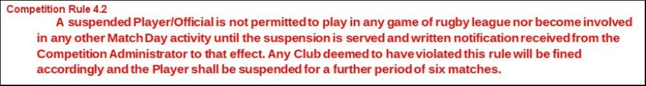

A Smith (NCL Administrator) Operations Dept, RFL, Cwm Ban Fawr, Llanfynydd, Carmathen, SA32 7UB.

